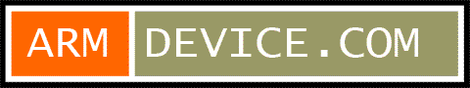 | Embedded Outsourcing Request Form

SECTION 1: Requester Information
Company Name: | Contactor Name: |  | Date:
Contactor Phone Number: |  | Email Address:
Address:

SECTION 2: Project Request Information (Multiple selection )
Hardware design | Demo boards manufacturing | Non-OS software
Bootloader Porting | OS Porting | Device Driver and Library
Application | UI/Graphic design | Document
Other:

SECTION 3: Hardware Request Information
EDA Tool: Mentor Orcad Pads Other _________ Version: __________
Operating Temperature: Commercial Industrial Military
EMC Requirement: CE FCC Other _________

SECTION 4: Software Request Information
Bootloader: U-Boot redboot CFE Other _________
OS: Linux Android Linux Windows CE VxWorks Other _________
Device Driver:
Application:

SECTION 5: Attachments
File name | Description

